Excerpts from various documents relating to the PAX.

DRD 5/28/03

PAX Wiring

David DeBoer
May 27, 2003

PAM (all pins internal)
RFout
Bias
+5

Detector
Bias – brown wire from OTX + GND
+5 – red wire to pin _____ + GND
Det – white to pin _____ + GND
-5 – blue wire to pin _____
Data – white wire to pin _____
Clock – yellow wire to pin _____
Load – green wire to pin _____

-5

Data
Clock
Load

RFin

OTX pairs (all pins internal, Black is ground)
Brown/black – to PAM
Yellow/black – +5 from pin _____
Red/black – +5 from pin _____
Blue/black – -5 from pin _____

PIC
+5 from

Current power supply – January 2003 (Black is ground)
From external pins:
White/black – -12 from pins 1/6
Orange/black – +6 from pins 2/7, 3/8, 4/9

To internal pins:
Yellow/black – +5 to pin ______ (see yellow/black under OTX)
Red/black – +5 to pin ______ (see red/black under OTX)
Blue/black – -5 to pin ______ (see blue/black under OTX)

Using the f/o detector



Excerpts from signal path memo (DRD March 2002)

The Post-Amp Module (PAM)
One of the main points of this exercise is to determine the gain profile of the post-amp module, or PAM. This module will consist of a low-pass filter (f_{c}~15 GHz), a high-pass filter (f_{c}~200 MHz), several gain stages and attenuators. The gain element is taken to be an RF Nitro NBB-310 wideband amplifier, and the specs were taken from their web-site (www.rfnitro.com). A constant noise figure of 4.9 dB was assumed (which is their quoted 3 GHz value, and the only value quoted). Attenuators are modeled as being constant with frequency at their nominal value. S₂₁ for the NBB-310 is shown in Figure 3, and are used as the gain values.
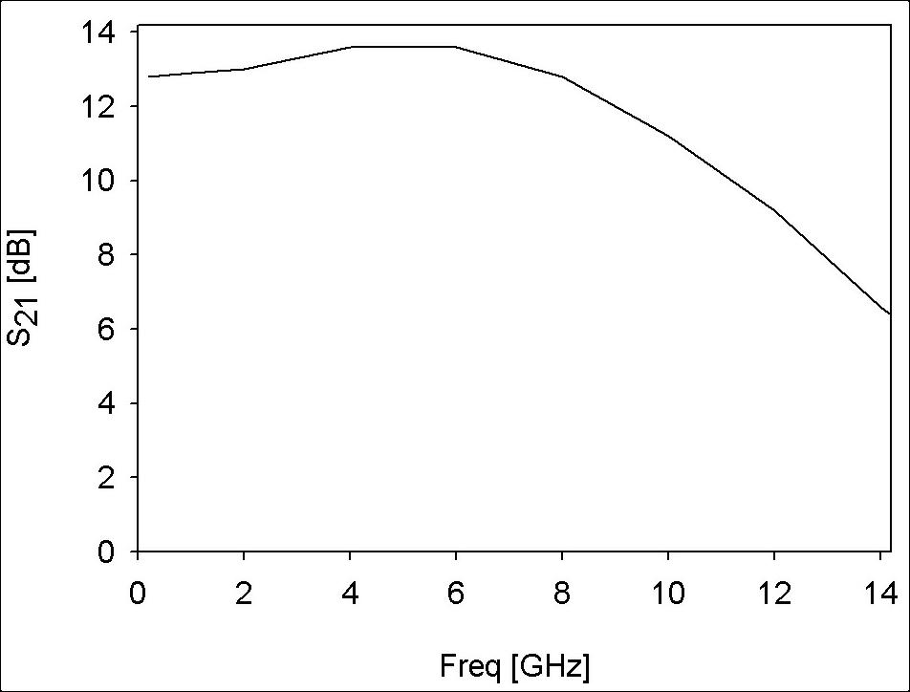
Figure 3: Gain plot of the RF Nitro NBB-310.
The low-pass filter is modeled as a 5 pole Butterworth with a 3-dB cut-off frequency of 14 GHz. The High-pass filter is modeled as a 7 pole Butterworth with a 3-dB cut-off frequency of 0.4 GHz. Both are assumed to have 2 dB of insertion loss. The combination is shown in Figure 4.
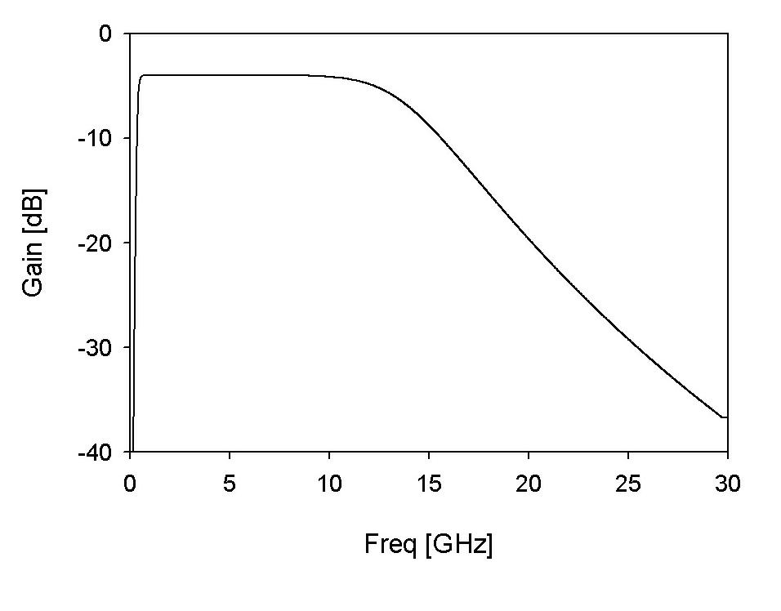
Figure 4: Combination of the LPF and HPF in the PAM.

The integrated power from the PAM should be about –11.5 dBm to properly feed the fiber-optic (f/o) link. This is accomplished with 5 NBB-310’s and 4 pads: a 10-dB, 2 6-dB and 1 2-dB pads. The resultant integrated power is –11.6 dBm. The mean output power is shown in Figure 5 and the net gain and noise temperature are shown in Figure 6.

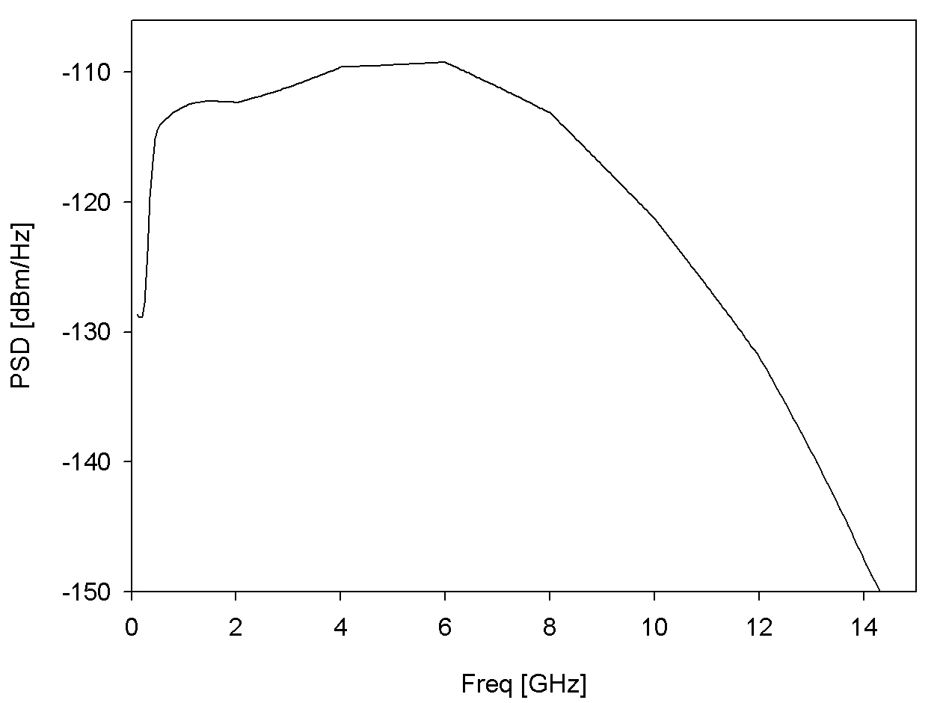
Figure 5: The mean output power from the PAM, incident on the fiber-optic link.

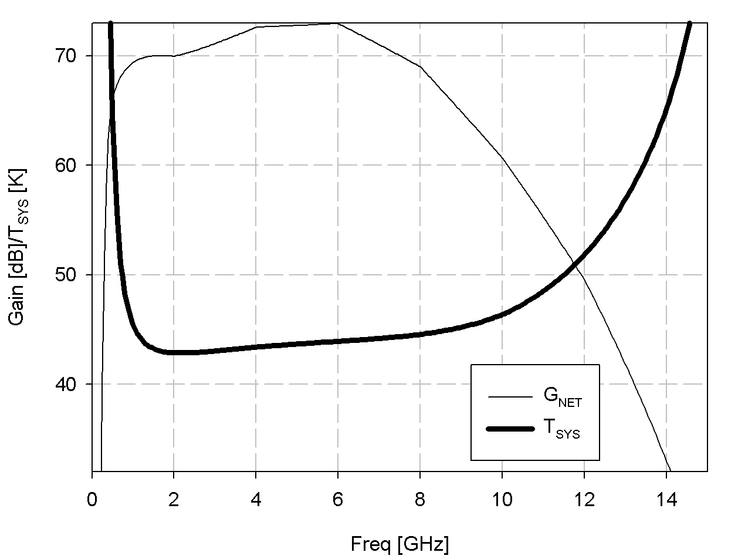
Figure 6: Net gain out of the post-amp module (narrow line) and system temperature (wide line).

Fiber-Optic Link
The fiber-optic link is a Fujitsu FLD5F10NP, with an assumed constant 42 dB noise figure. The gain profile is shown in Figure 7 [Ed Ackerman, personal communication].

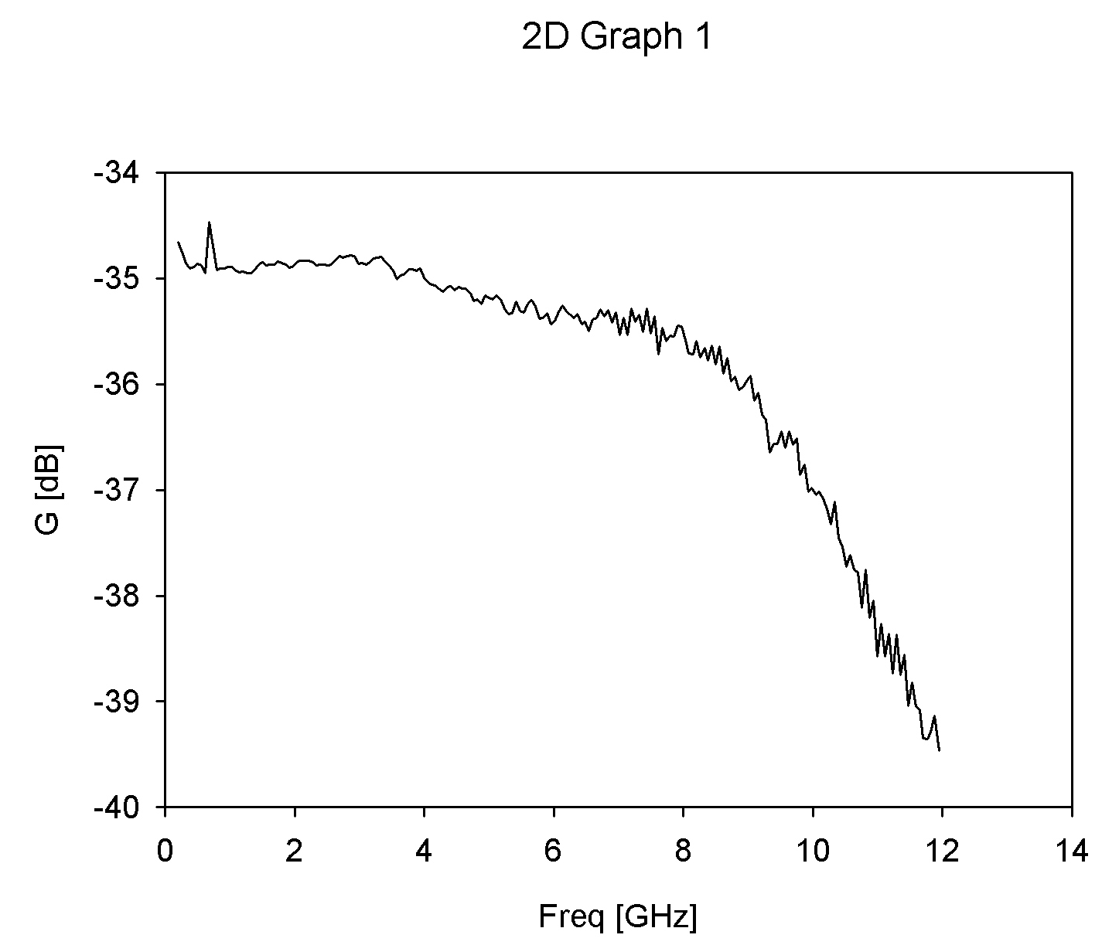
Figure 7: Gain profile of the Fujitsu analog fiber-optic link.

The mean output power from the fiber-optic link is shown in Figure 8, and the net gain and system temperature are shown in Figure 9. The integrated power is –46.8 dBm. The LNA output power is also shown to note that the level into the RF converter board is at the same level as the power out of the LNA (and isn’t shaped as prettily).

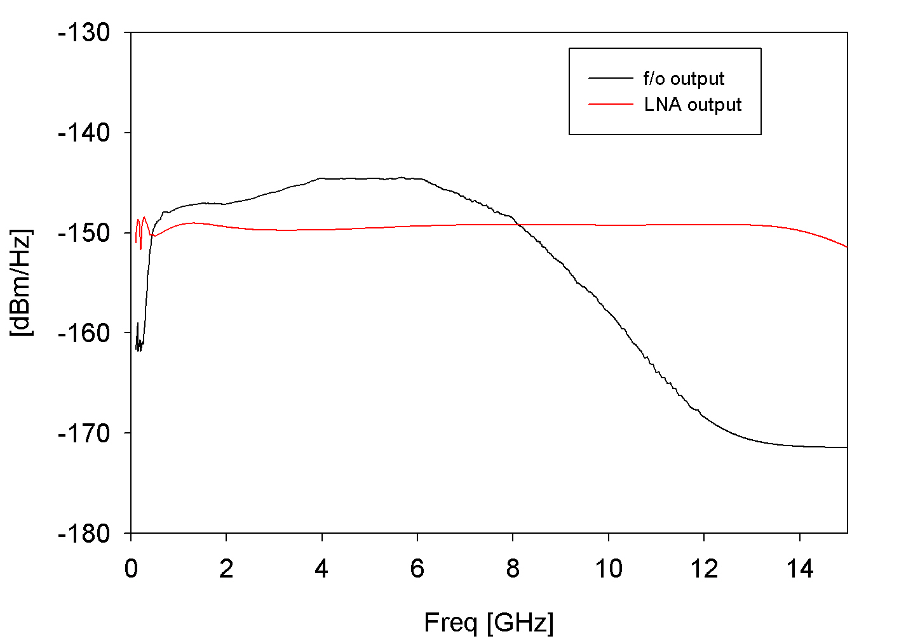
Figure 8: Mean output power of the fiber-optic link, along with the LNA output power. The front-end really just conveys the LNA power back to the user (and shapes the spectrum).
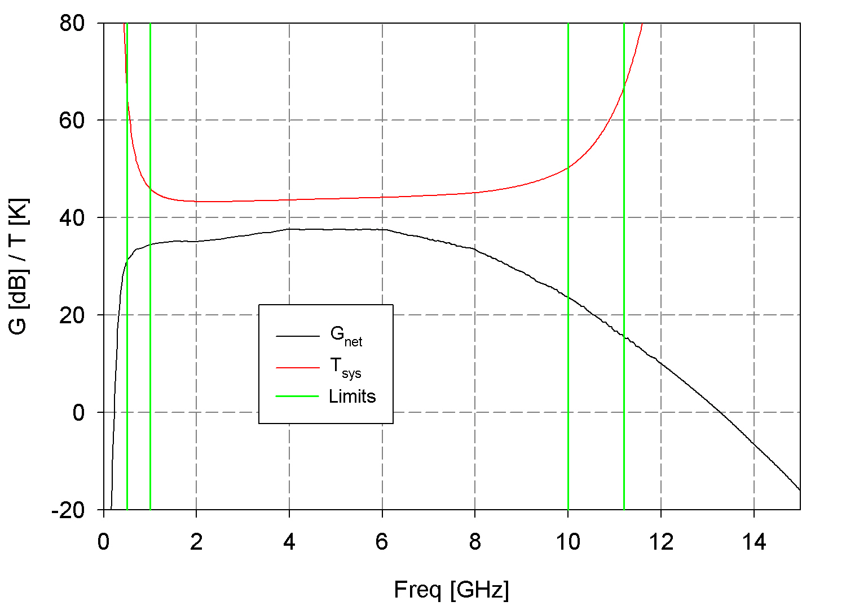
Figure 9: Net gain and system temperature out of the fiber-optic system. The green lines show the 1-20 GHz range (inner pair) and the 0.5-11.2 GHz range.

